PBO - Project 2

Code :

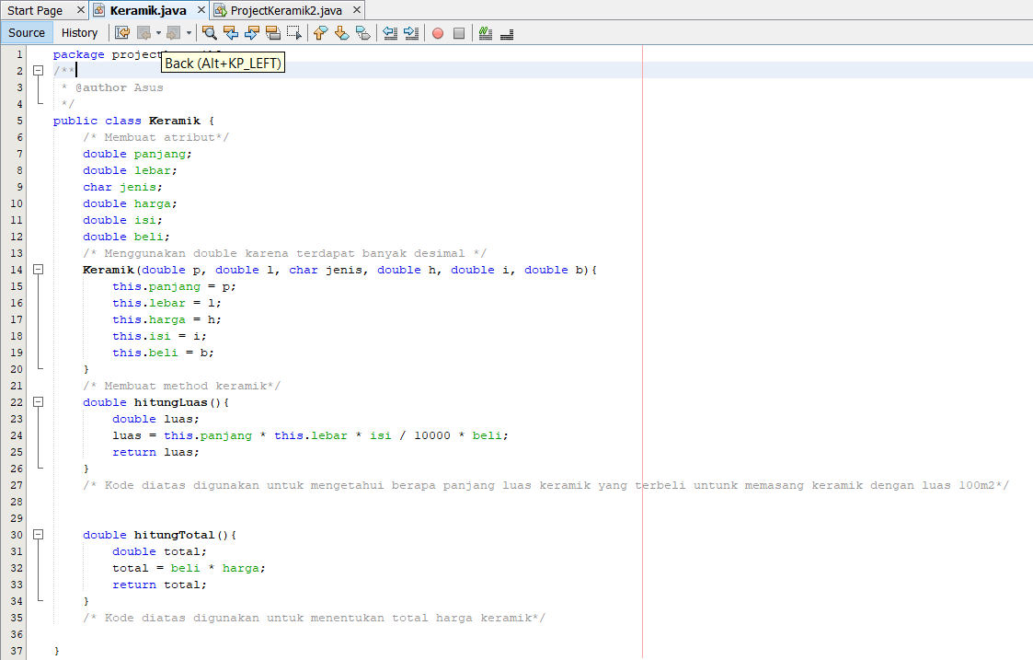

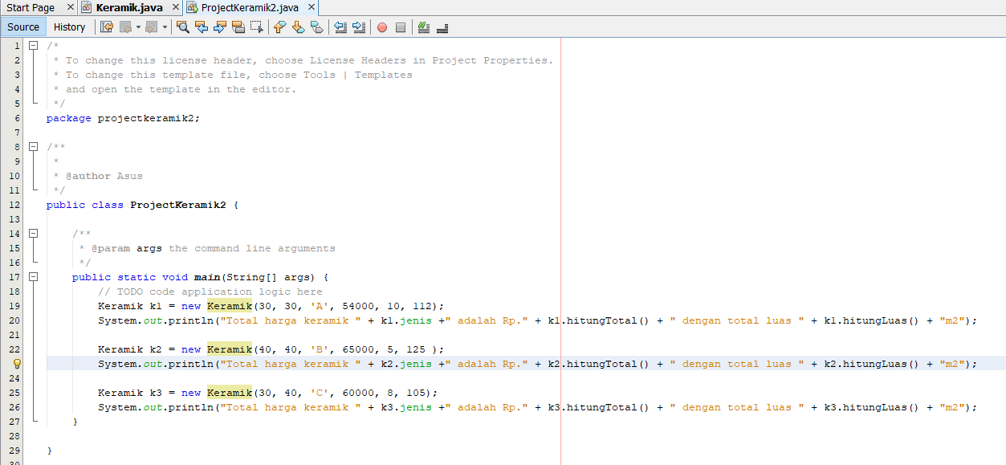

Output :

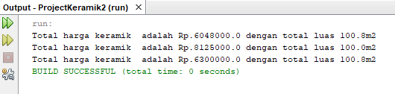

Github link

<https://github.com/grimalvez/PBO/projects>